Lab Report
On
“SOFTWARE PROJECT MANAGEMENT”

In partial fulfillment of the requirements for the degree of
Bachelor of Computer Applications

Submitted by:
Anjan Khadka (113102067)

Under the esteemed guidance of
Aayush Chaudhary
Course Instructor


FACULTY OF HUMANITIES AND SOCIAL SCIENCE
SWASTIK COLLEGE
CHARDOBATO, BHAKTAPUR, NEPAL

Acknowledgement
I would like to express my sincere gratitude to Mr. Aayush Chaudhary, our course instructor for providing valuable guidance and support throughout the Software Project Management laboratory sessions. The practical exercises helped me understand important concepts such as project planning, task scheduling, precedence relationships, Gantt charts, network diagrams, and project management tools. I am thankful for the clear instructions and practical knowledge that made it easier to apply the concepts learned in class. I also appreciate the support and cooperation of my classmates during the completion of these experiments. These laboratory activities provided me with an opportunity to gain practical experience in planning and managing software projects. I am grateful to everyone who contributed directly or indirectly to the successful completion of this lab report. Finally, I would like to thank my instructor for encouraging us to learn and explore different project management techniques and tools.

LAB REPORT OVERVIEW
Software Project Management

S.N. | Experiment / Question |  | Page No.
1 | Trello features and project  management
2 | Precedence Diagram Method
3 | Gantt Chart and Network Diagram
4 | Purpose of PDM
5 | MS Project: Network Diagram &  Gantt Chart
Course Instructor: Aayush Chaudhary  ………………………….  Signature |  | …….………………………….  External Examiner (Signature)

1. Explain all the features or functions of Trello in relation to your 7th-semester project and managing it effectively.
a. Creating Boards
The first step in managing the project using Trello is to create a dedicated board for the project. The board acts as the central workspace where all project activities, tasks, team members, deadlines, and progress can be managed.
For our project, the board was created with the name “SPM Lab – E-Commerce Website Development.”
Steps to create the board:
- Go to Trello and log in to the account.
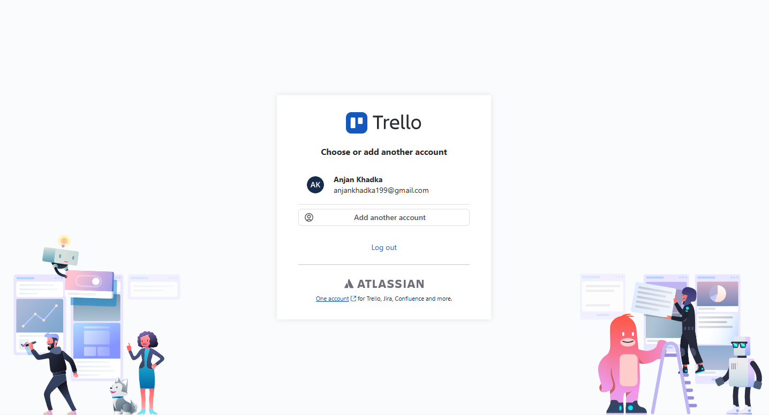
Figure: Trello Auth Interface
- Click on the Create option and select Create Board.
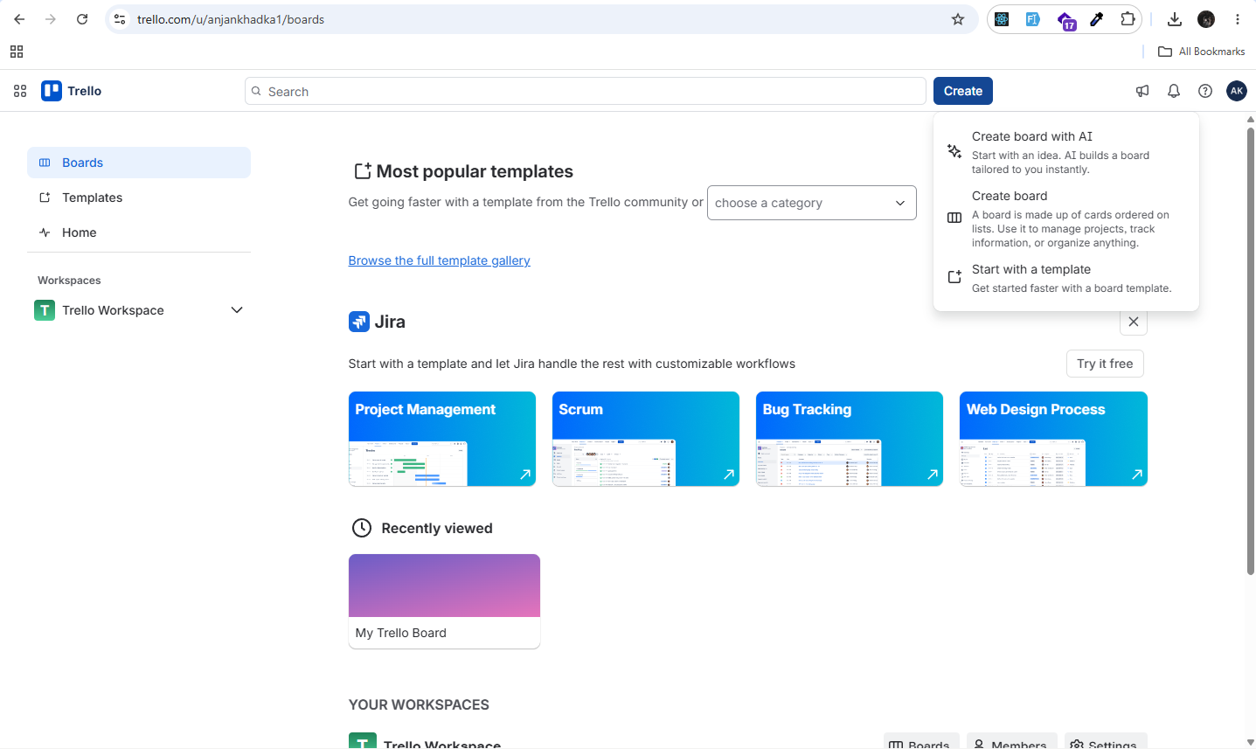
Figure: Trello Dashboard Interface
- Enter a relevant project name, such as SPM Lab – E-Commerce Website Development.
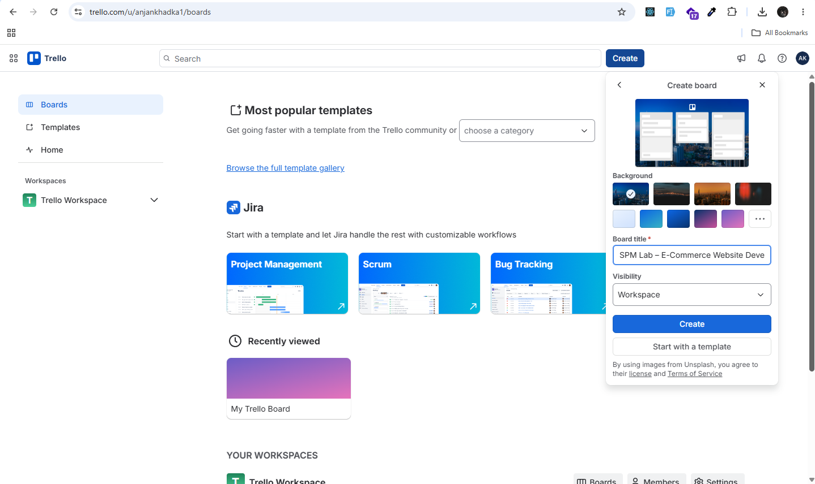
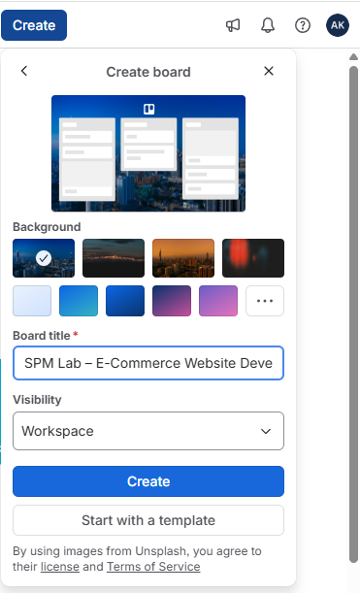
Figure: Creating new Board on trello
- Select a suitable background or theme for the board if required.
- Click Create to create the project board.
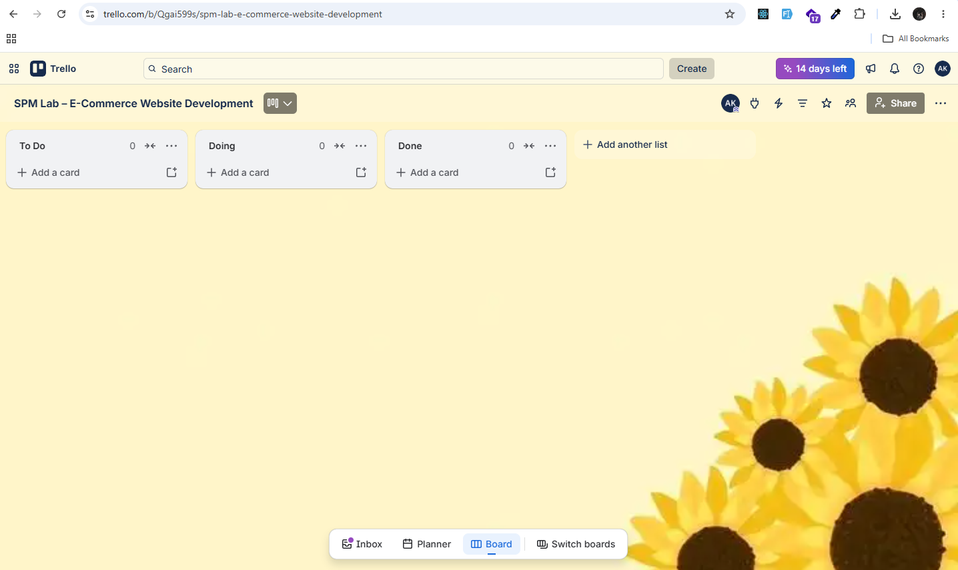
Figure: Project board Interface of trello
- The created board is then used by the team to manage and monitor the E-Commerce project.
b. Lists and Cards
Trello allows the project to be divided into different lists, where each list represents a particular stage of the project. Cards are then created inside these lists to represent individual tasks or activities.
For our E-Commerce project, the following lists were created:
- Backlog
- To Do
- In Progress
- Review
- Testing
- Bug Fixing
- Done
These lists represent the flow of tasks throughout the software development process.
Steps:
- Click on Add another list to create a project stage.
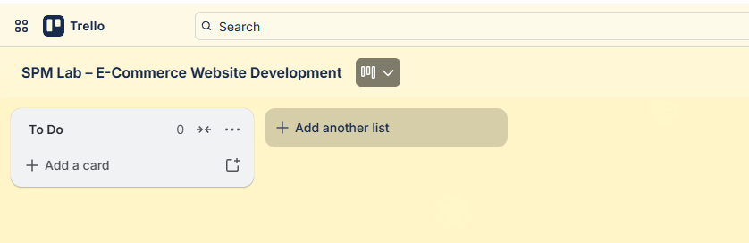
Figure: Adding another list on board
- Enter the name of the list, such as To Do.
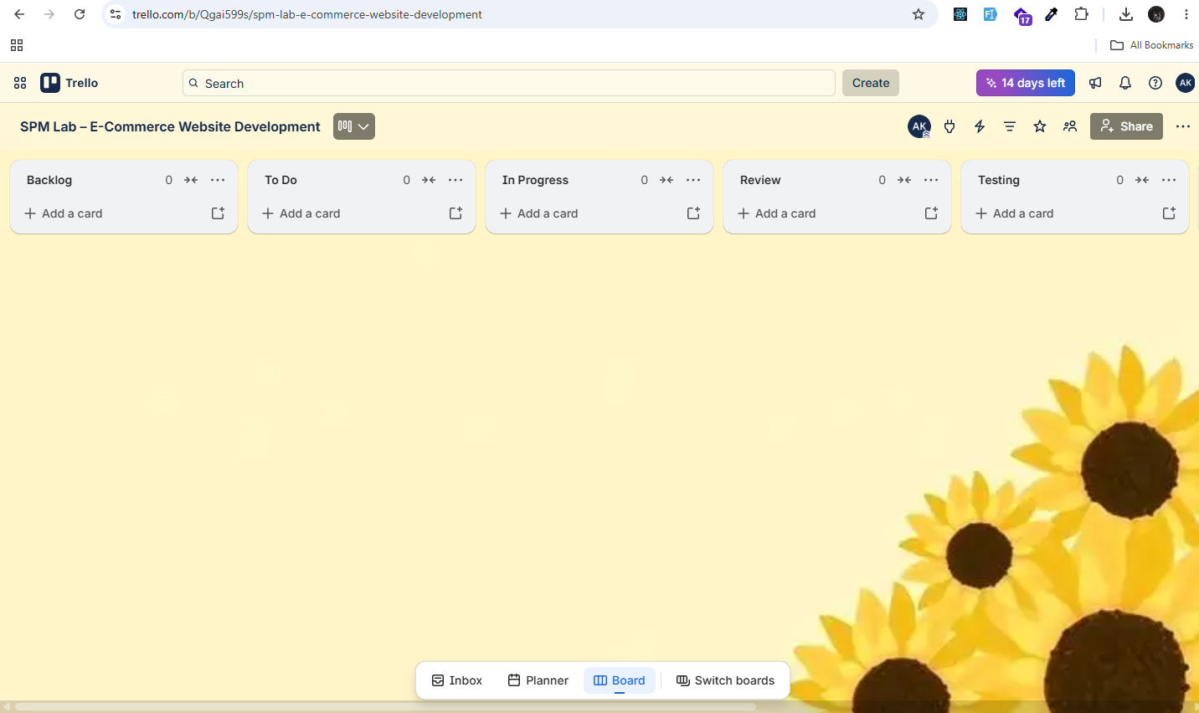
Figure: lists on board
- Repeat the process to create the remaining project stages.
- Click Add a card inside the appropriate list.
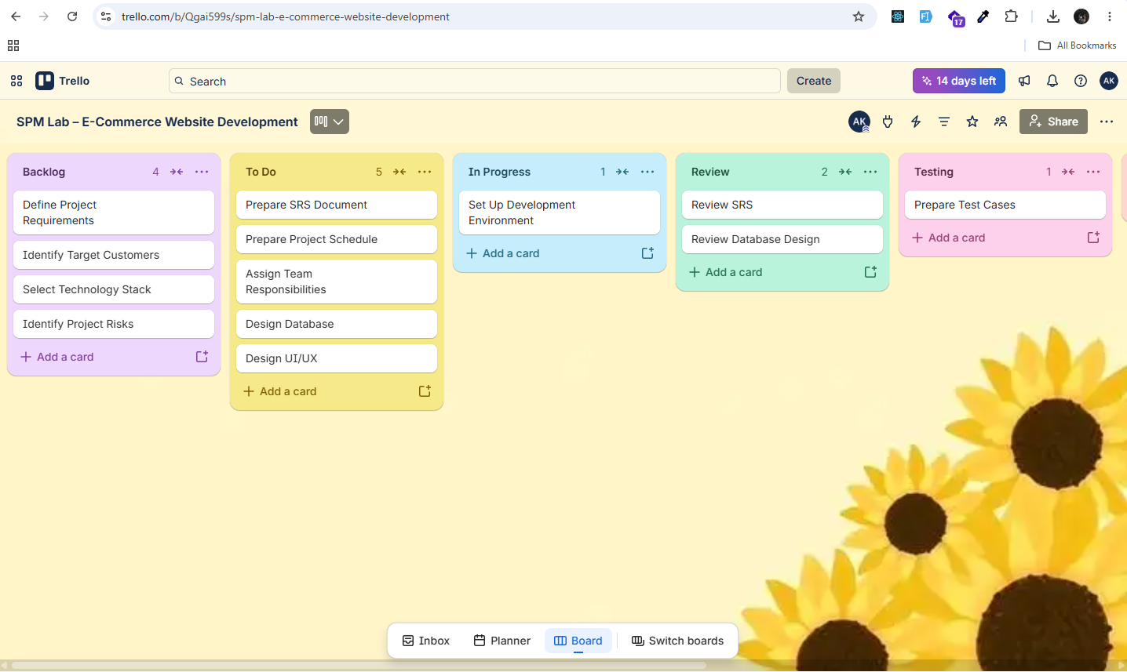
Figure: Adding card to the appropriate list
- Enter the name of the task and create the card.
- Tasks can later be moved between lists according to their progress.
For example, a “Design UI/UX” card can initially be placed in To Do, moved to In Progress when development starts, and finally moved to Done after review and approval.
c. Task Management
Trello cards are used to represent individual tasks or activities within the E-Commerce project. Each card can contain additional information such as descriptions, checklists, due dates, attachments, and labels. This helps the team understand the task clearly and manage it effectively.
For example, the “Prepare SRS Document” card was created to manage the preparation of the Software Requirements Specification.
Adding Description: A description was added to explain the purpose and scope of the task.
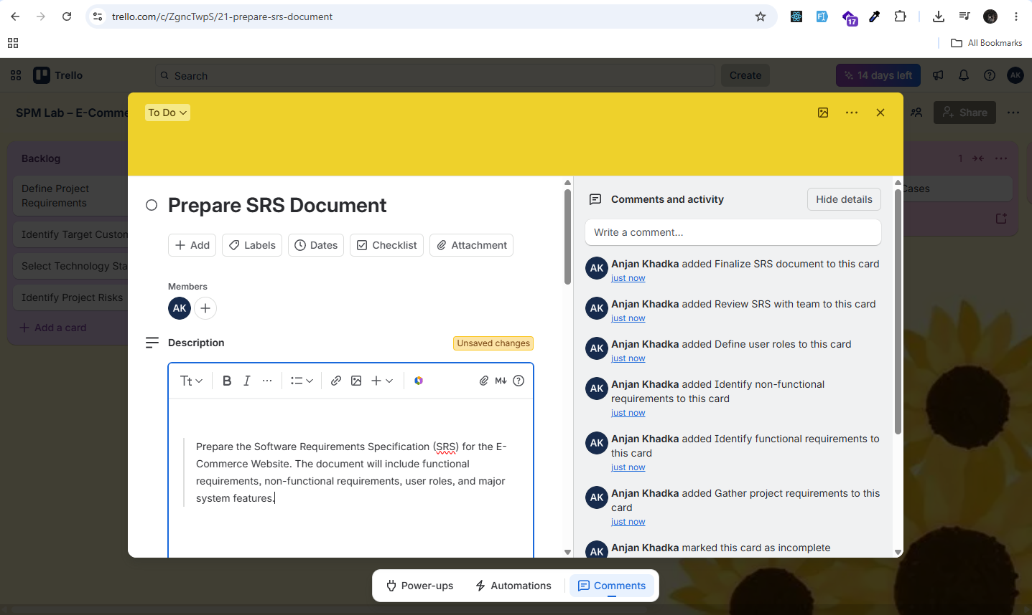
Figure: Adding description on particular card
Prepare the Software Requirements Specification (SRS) for the E-Commerce Website, including project scope, functional requirements, non-functional requirements, user roles, and system constraints.
Adding Checklists: A checklist was added to divide the task into smaller activities.
- Gather project requirements
- Define project scope
- Identify functional requirements
- Identify non-functional requirements
- Define user roles
- Review SRS with the team
- Finalize SRS
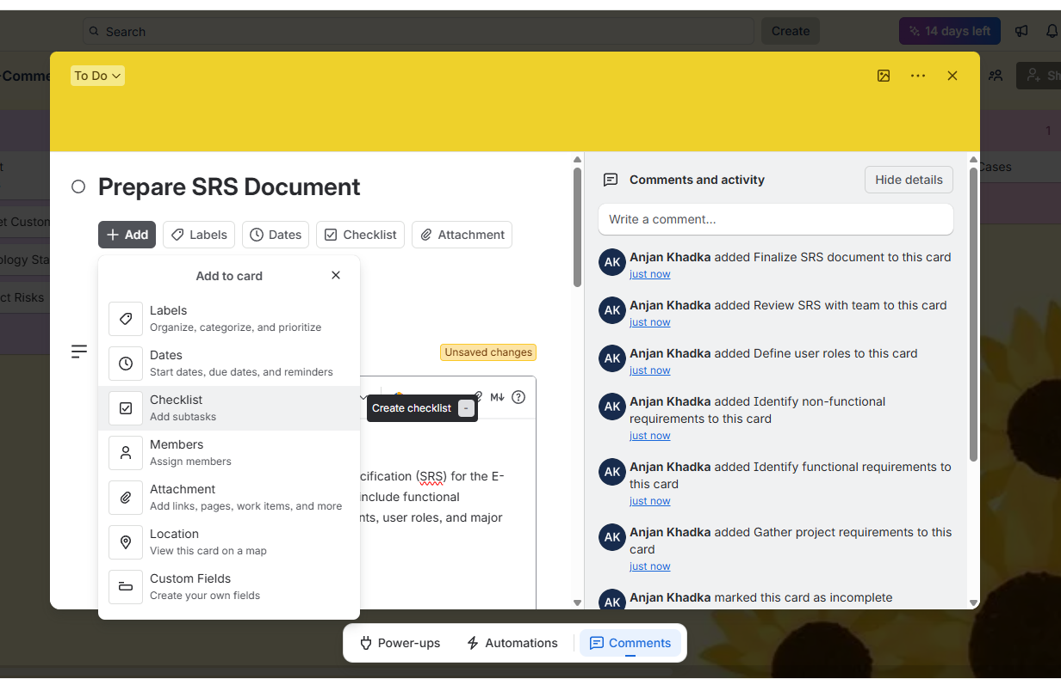
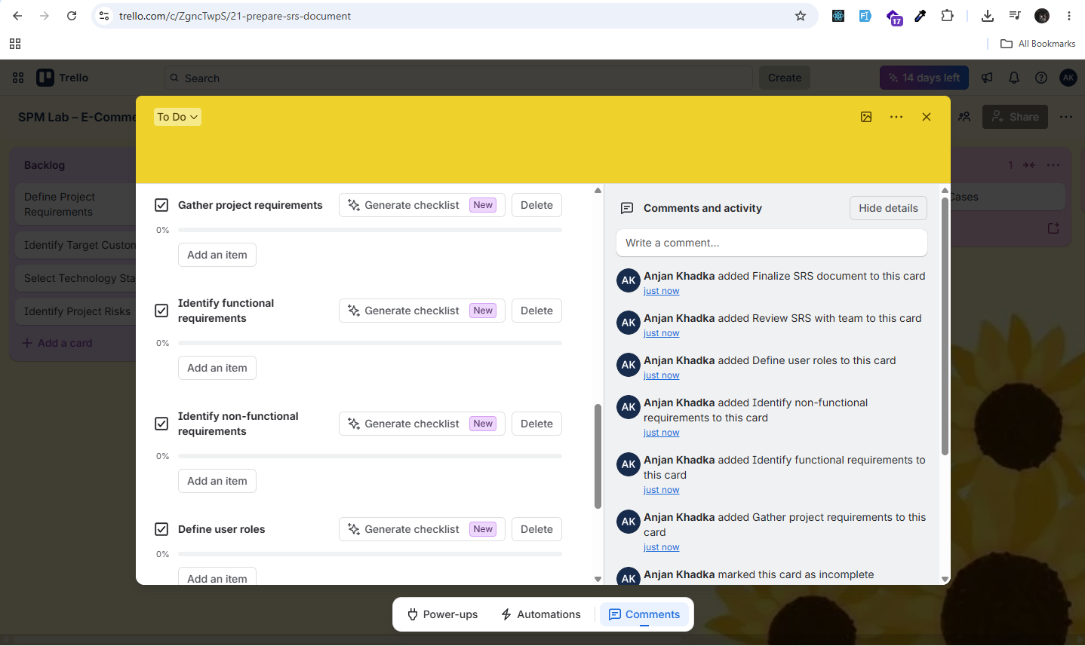
Figure: Adding checklist on card
Adding Due Date: A due date was assigned to ensure that the task is completed within the planned schedule.
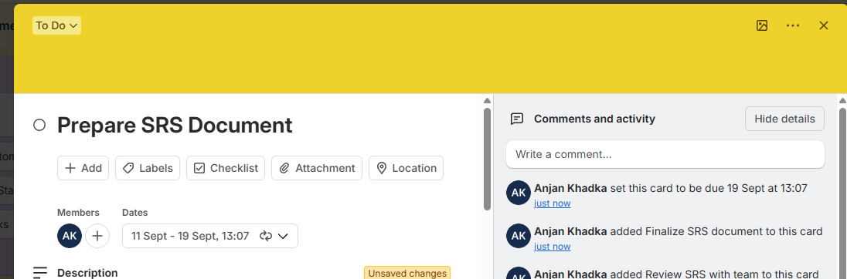
Figure: Adding due date on card
Adding Attachments: An SRS reference document was attached to the card so that team members can use it as a guide while preparing the project SRS.
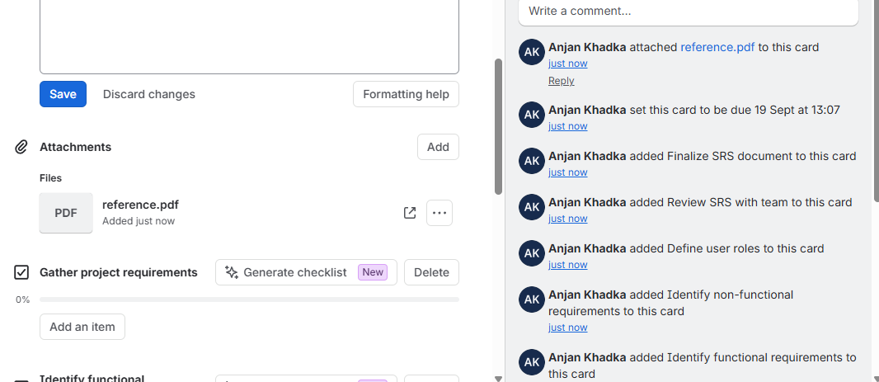
Figure: Adding attachment on card
Adding Labels: Labels were added to categorize and identify the task easily. For example, the Documentation label was used for the SRS task.
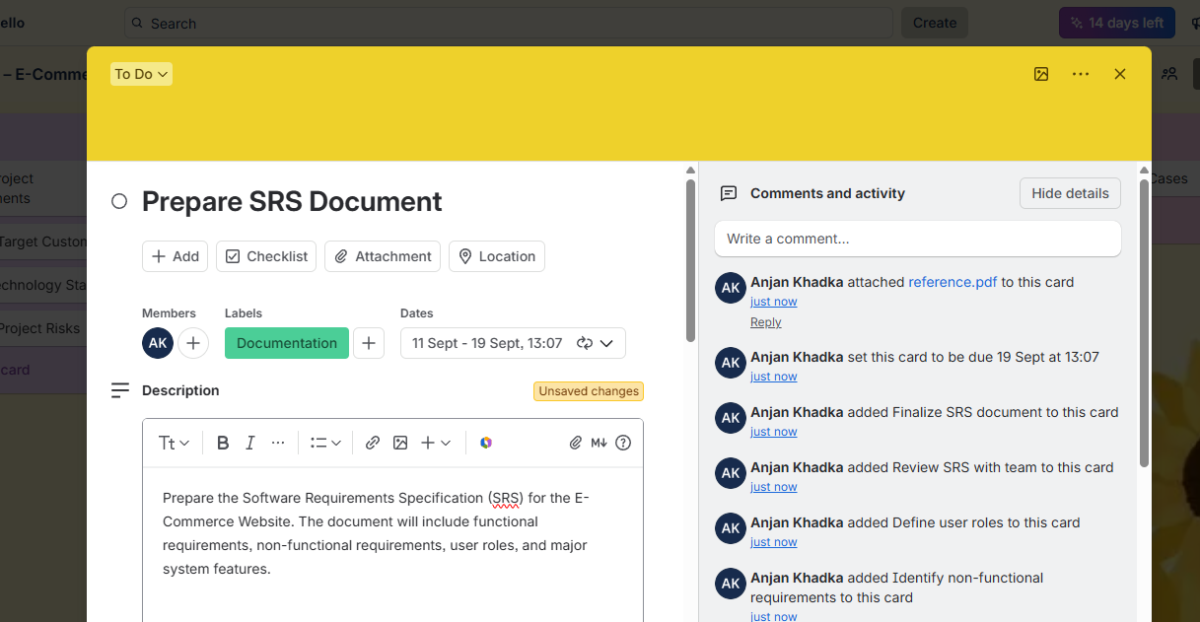
Figure: Adding label on card
d. Assigning Tasks
Trello allows tasks to be assigned to specific team members. This helps distribute responsibilities among team members and makes it clear who is responsible for completing each task.
Steps:
- Add the required team members to the Trello board/workspace.
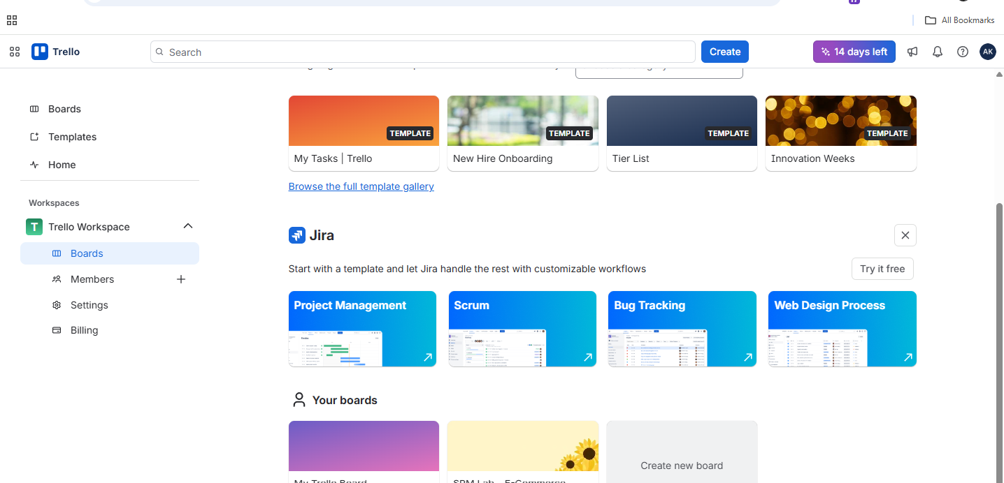
Figure: Trello Dashboard Interface
- Open the card for which a member needs to be assigned.
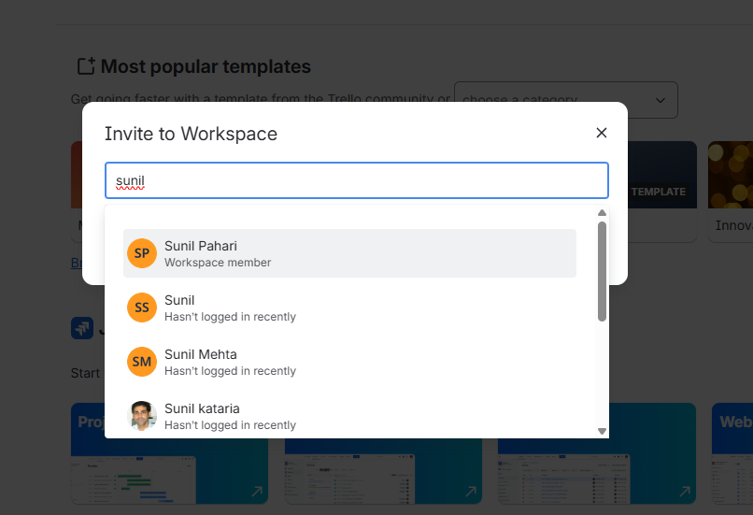
Figure: Adding members on specific workspace
- Select the Members option.
- Select the appropriate team member.
- The member's profile will then appear on the card.
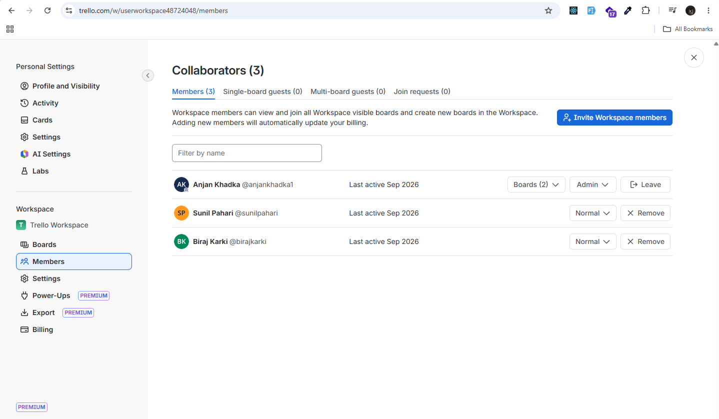
Figure: Collaborators list on workspace
For example, the “Design UI/UX” card can be assigned to the team member responsible for UI/UX design, while “Design Database” can be assigned to the member responsible for database-related activities.
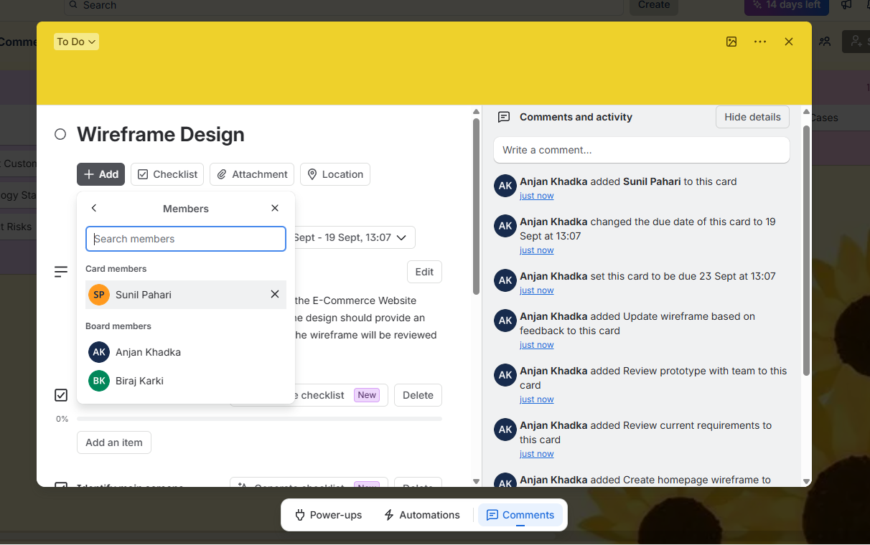
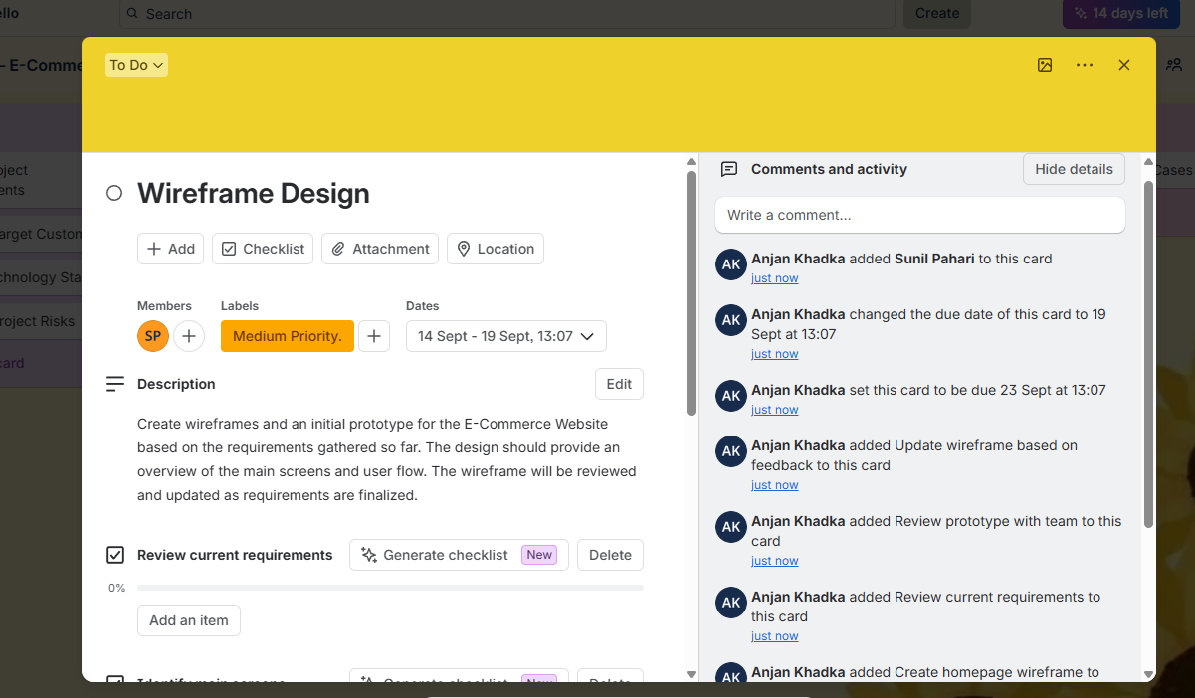
Figure: Assigning card to members
e. Collaboration
Trello provides collaboration features that allow team members to communicate and share information directly within project cards. Team members can add comments, mention other members, and attach relevant files.
For example, while preparing the SRS, a team member can leave a comment requesting a review from another member.
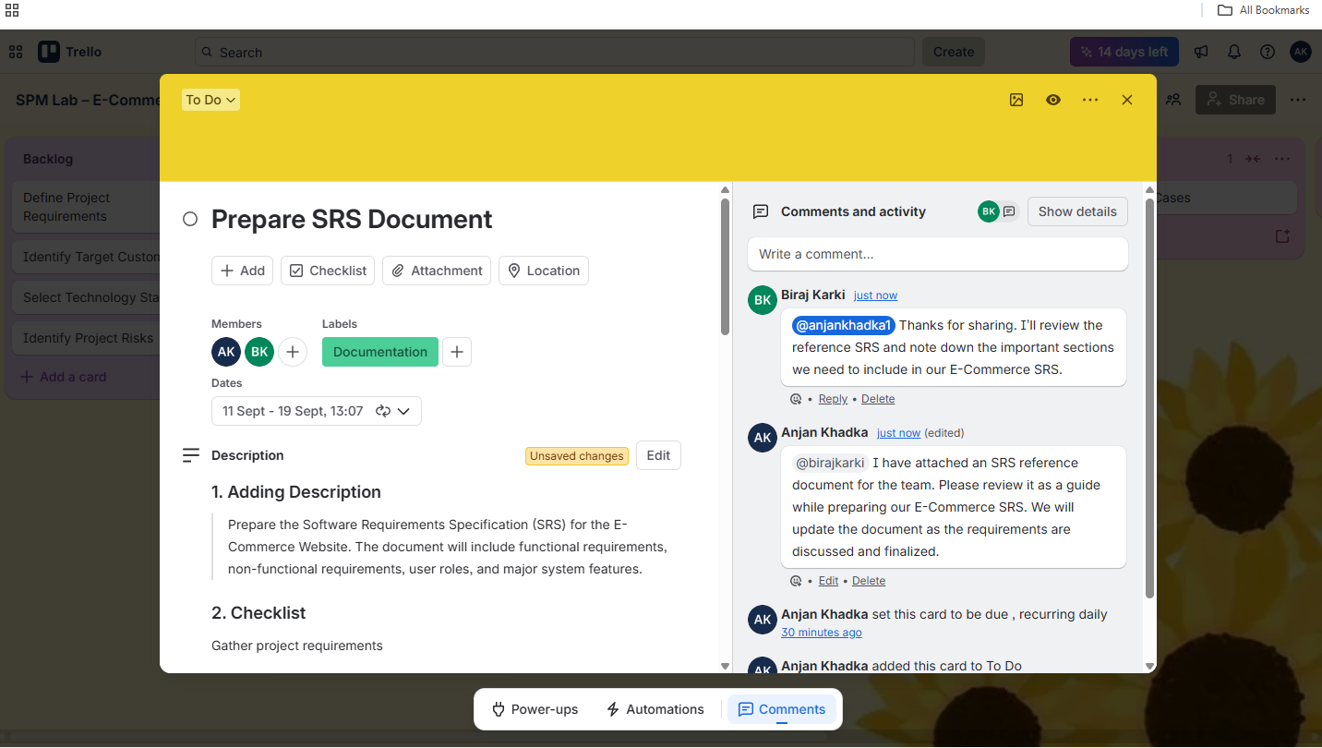
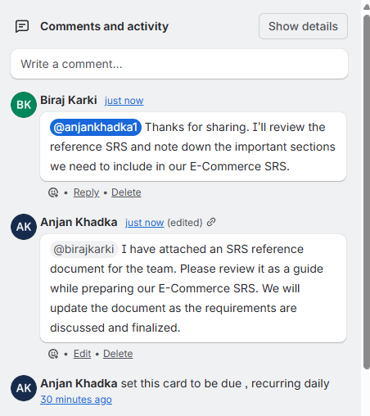
Figure: Communication within project cards
Another team member can reply to the comment and provide feedback or confirm that the document has been reviewed.
This helps maintain project-related communication in one place instead of relying only on external communication tools.
f. Prioritization
Trello allows tasks to be prioritized by rearranging cards within a list using its drag-and-drop interface. This helps the team focus on the most important or urgent activities first.
For example, within the To Do list, tasks can be arranged according to their importance:
- Finalize Project Requirements
- Prepare SRS
- Design UI/UX
- Design Database
- Prepare Project Documentation
The most important tasks are placed near the top of the list. If project requirements are still being finalized, the SRS task can be given higher priority because other activities may depend on the finalized requirements.
g. Tracking Progress
Trello provides a visual way to monitor the progress of the project. As tasks move through different lists, team members can easily identify which tasks are pending, currently being worked on, under review, being tested, or completed.
For example, a task can follow the workflow:
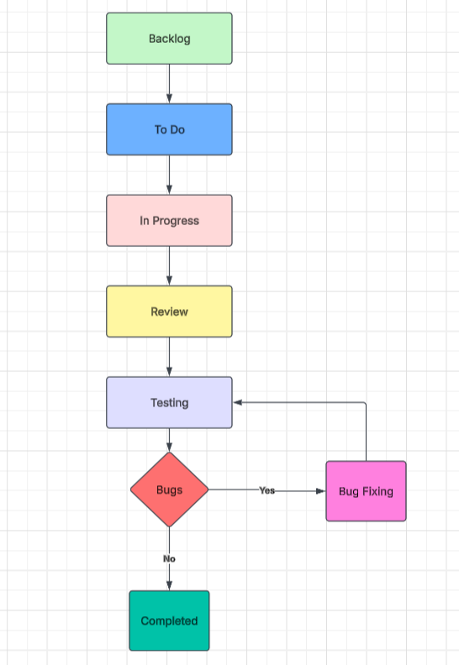
Figure: Task Workflow of project
If a problem is identified during testing, the task can be moved to Bug Fixing. After the issue is resolved, it can be moved back to Testing for verification. Once it passes testing, it can be moved to Completed.
Trello also provides different views for monitoring the project.
1. Timeline View
The Timeline View provides a visual representation of project activities over a period of time. It helps the team plan tasks, understand deadlines, and identify overlapping activities.
For example, the team can use the timeline to schedule activities such as SRS preparation, UI/UX design, database design, development, and testing.
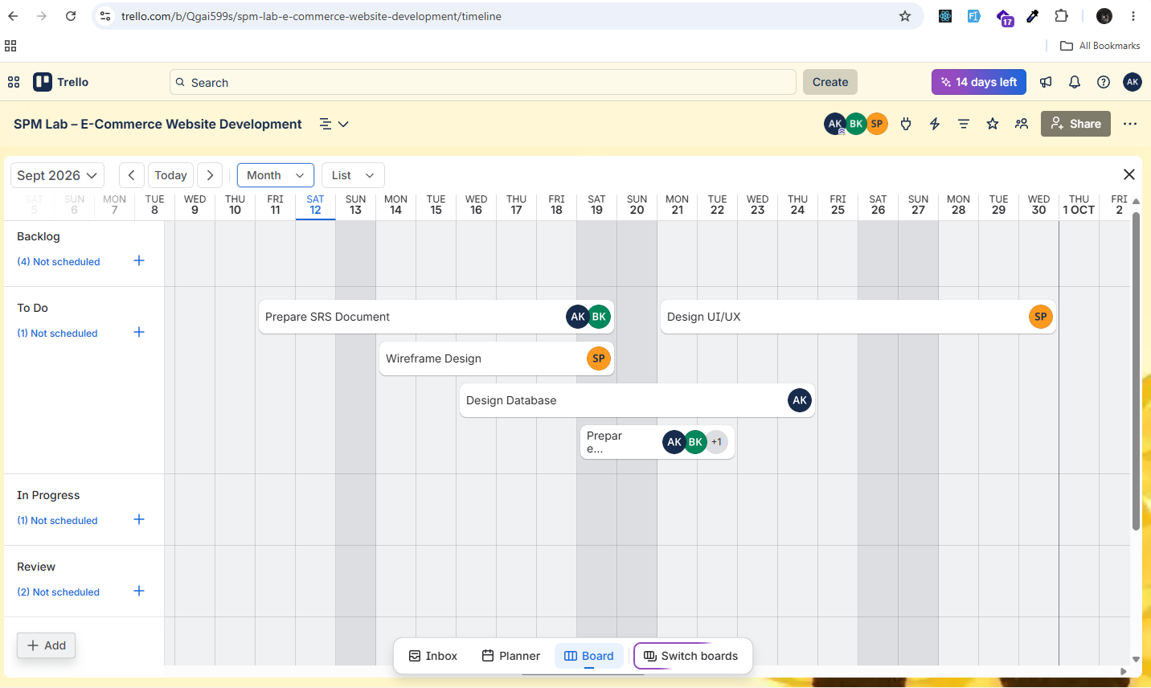
Figure: Timeline View of the project.
2. Dashboard View
The Dashboard View provides an overview of the project's current status. It can help the team understand the number of tasks in different stages and monitor the overall workload and progress.
For example, the team can see how many tasks are currently in To Do, In Progress, Testing, Bug Fixing, and Done.

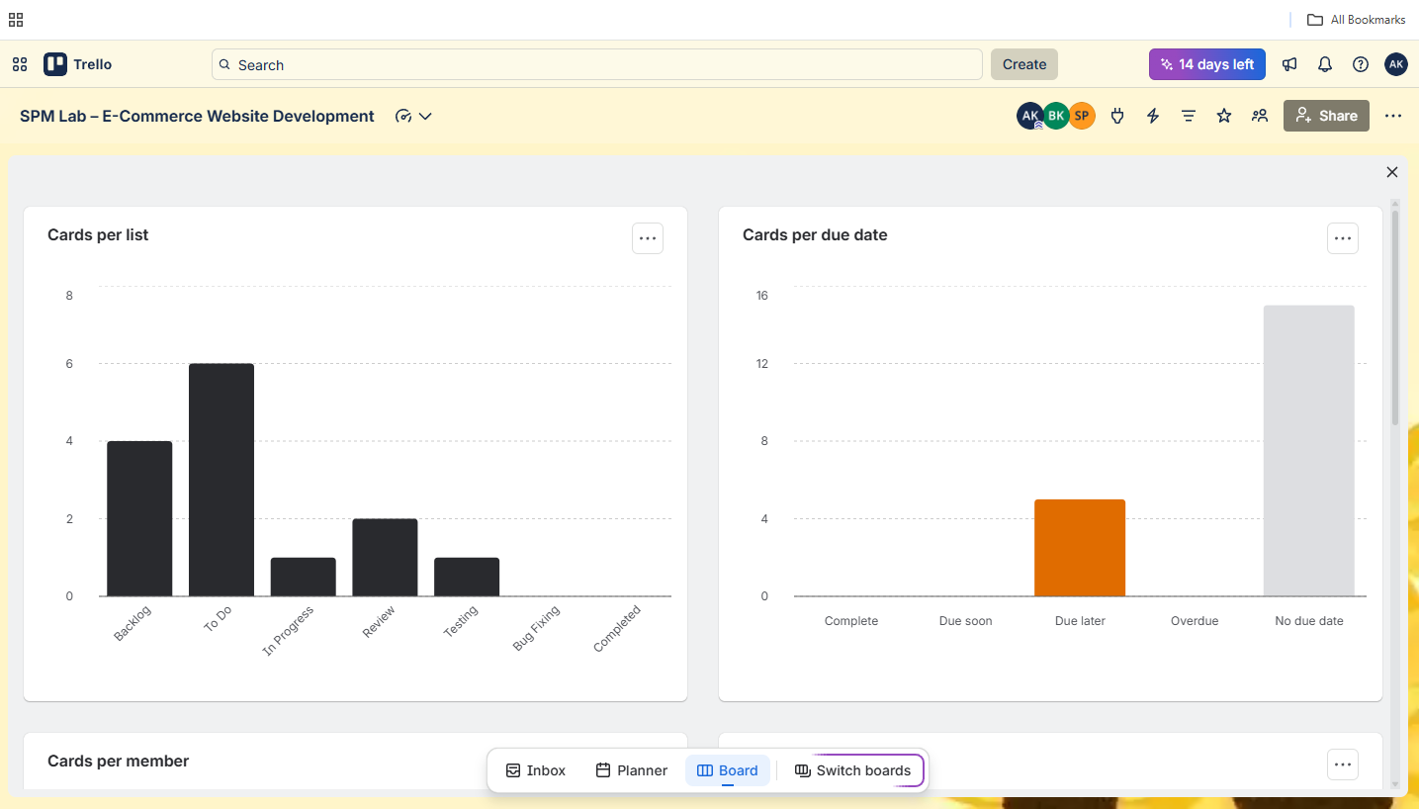
Figure: Dashboard View.
3. Calendar View
The Calendar View displays tasks according to their assigned due dates. It helps the team keep track of upcoming deadlines and ensures that important activities are completed on time.
For example, deadlines for SRS preparation, wireframe design, database design, testing, and project documentation can be viewed through the calendar.
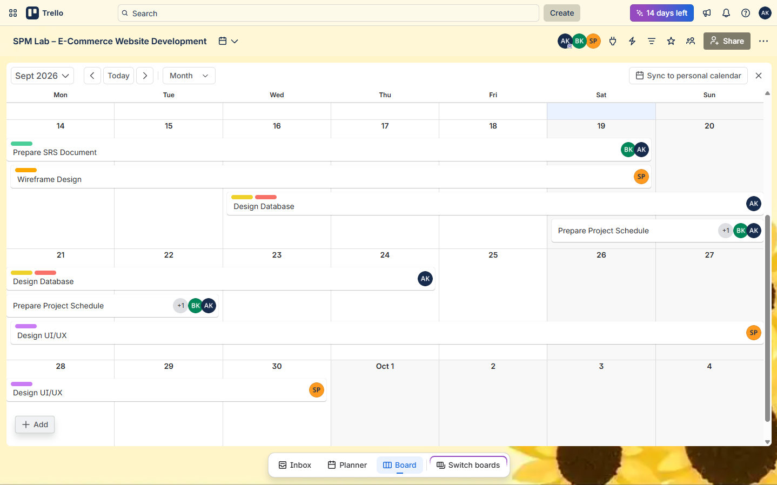
Figure: Calendar View showing project tasks and deadlines.

2. What is a Precedence Diagram Method?
The Precedence Diagram Method (PDM) is a widely used project scheduling technique for representing the logical relationships and dependencies among various project activities. It provides a graphical representation of a project schedule network in which activities are represented by nodes or boxes, while arrows indicate the logical relationships between those activities. PDM is also commonly referred to as the Activity-on-Node (AON) method.
The primary objective of PDM is to develop a clear and logically structured project schedule that accurately illustrates the sequence in which activities should be performed. Unlike traditional scheduling approaches such as Program Evaluation and Review Technique (PERT) and the Critical Path Method (CPM), which were initially focused primarily on finish-to-start relationships, PDM allows a project schedule to incorporate a wider range of dependency relationships. This provides greater flexibility and enables project managers to represent complex activity sequences more realistically.
PDM is particularly valuable during project planning and scheduling because it enables project managers to visualize the interrelationships among activities, determine their logical sequence, and establish the overall duration of the project. By identifying the dependencies between activities, PDM also supports the determination of the critical path, which consists of activities that collectively influence the minimum time required to complete the project.
The Precedence Diagram Method provides several important advantages in project planning and control:
- Improved visualization: PDM presents project activities and their relationships in a graphical form, making the overall project structure easier to understand and communicate.
- Clear identification of dependencies: It helps determine which activities must be completed or initiated before other activities can proceed.
- Effective schedule development: PDM assists in establishing the planned start and finish times of activities, thereby supporting the development of a comprehensive project schedule.
- Critical path identification: By analyzing activity dependencies and durations, PDM can be used in conjunction with CPM to identify the sequence of activities that determines the project's overall completion time.
- Identification of scheduling constraints: The diagram can reveal potential bottlenecks, delays, and dependency-related constraints, allowing project managers to take appropriate corrective measures.
- Better project coordination: PDM facilitates coordination among different project teams by providing a common visual representation of activity sequences and dependencies.
- Integration with project management techniques: PDM can be effectively combined with techniques such as CPM and other scheduling tools to improve project planning, monitoring, and control.
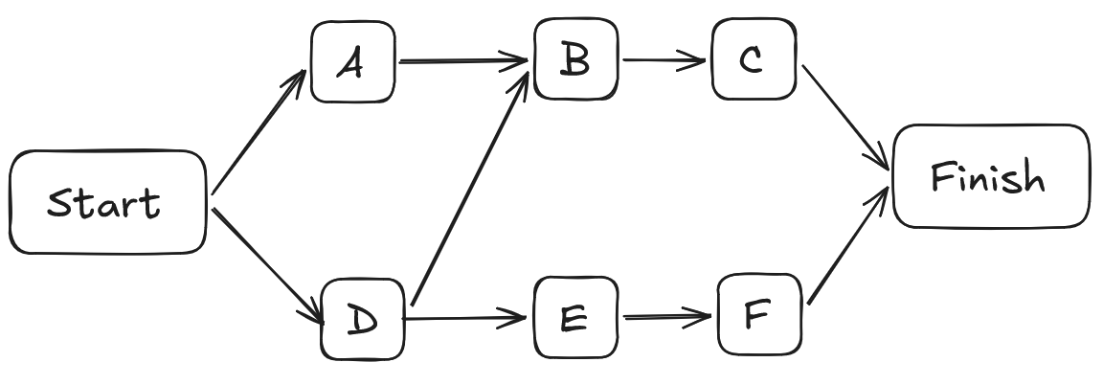
Figure: Precedence Diagram Method
The Precedence Diagram Method supports four fundamental types of logical relationships between predecessor and successor activities. These relationships provide flexibility in representing the actual sequence of work within a project.
1. Finish-to-Start (FS): In a Finish-to-Start relationship, the successor activity cannot begin until the predecessor activity has been completed. This is the most commonly used dependency in project scheduling.
2. Start-to-Start (SS): In a Start-to-Start relationship, the successor activity can begin only after the predecessor activity has started. This relationship is useful when two activities can be performed concurrently but require a defined starting relationship.
3. Finish-to-Finish (FF): In a Finish-to-Finish relationship, the completion of the successor activity is dependent on the completion of the predecessor activity. Both activities may proceed simultaneously, but their finishing points are logically related.
4. Start-to-Finish (SF): In a Start-to-Finish relationship, the successor activity cannot finish until the predecessor activity has started. This type of relationship is rarely used in conventional project scheduling but can be applicable in specific operational situations.
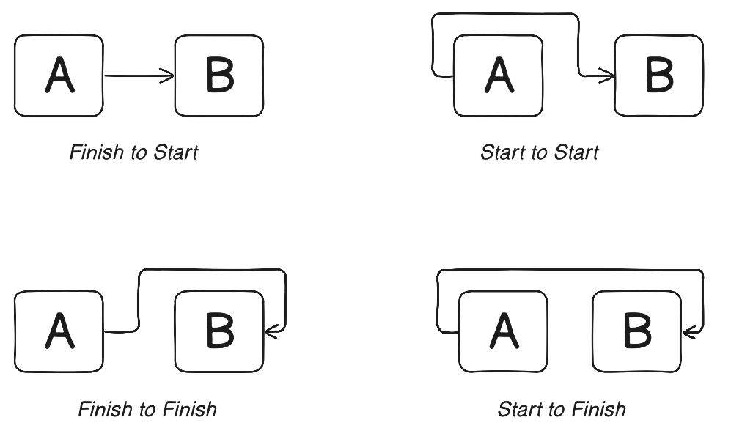
Figure: PDM Logical Relationship
The Precedence Diagram Method (PDM) is an effective scheduling technique that provides a structured and visual representation of project activities and their logical dependencies. By incorporating four different types of activity relationships—Finish-to-Start, Start-to-Start, Finish-to-Finish, and Start-to-Finish—PDM enables project schedules to represent complex sequences of work more accurately than methods based solely on finish-to-start relationships. Consequently, it serves as an important tool for project planning, scheduling, critical path analysis, dependency management, and overall project control.

3.What is a Gantt Chart and Network Diagram?
Gantt Chart
A Gantt chart is a project management tool used to plan, schedule, and track tasks. It shows tasks on a timeline using horizontal bars. The length of each bar shows how long a task will take, while its position shows when the task starts and ends. Gantt charts also show task dependencies, milestones, and progress. They help project managers understand the project schedule and monitor its progress easily.
Features of a Gantt Chart:
- Timeline:
  - Shows time in days, weeks, months, or other periods.
  - Helps identify when tasks start and finish.
- Activities:
  - Lists project tasks on the left side.
  - Each task is shown as a horizontal bar.
- Task Duration:
  - The length of the bar represents the time needed to complete the task.
  - The position of the bar shows its start and end dates.
- Dependencies:
  - Lines or arrows show the relationship between tasks.
  - They indicate which task needs to be completed before another begins.
- Milestones:
  - Important events or achievements are shown as milestones.
  - They are often represented by diamond shapes.
- Progress Tracking:
  - Different colors or shading can show how much of a task has been completed.
  - This helps in monitoring project progress.
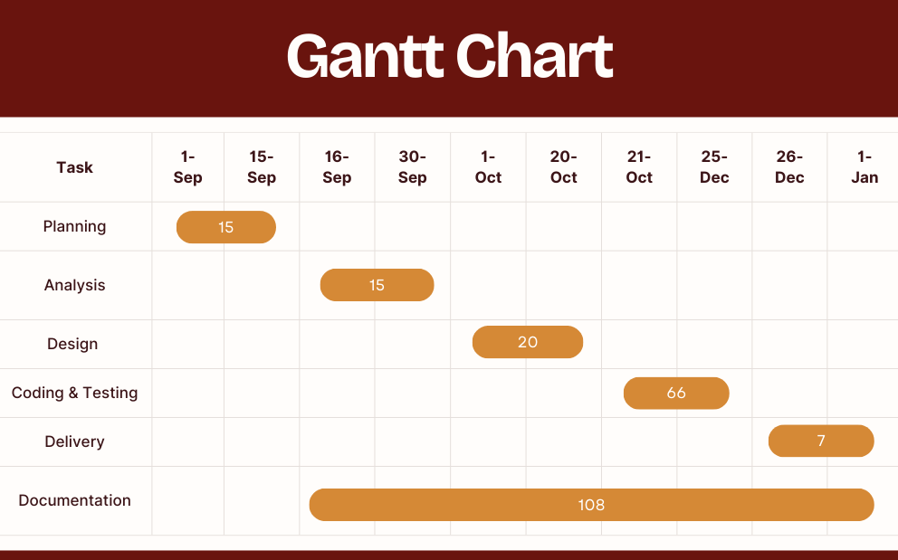
Network Diagram
A network diagram is a visual representation of project activities and the dependencies between them. It shows the logical sequence of tasks and how they are connected from the beginning to the completion of a project. Network diagrams are useful for project scheduling, dependency analysis, and identifying the critical path.
Features of a Network Diagram:
- Activities/Nodes:
  - Represent project tasks or activities.
  - May include information such as duration and resources.
- Arrows/Connections:
  - Show the relationship and flow between activities.
  - Indicate the order in which tasks should be completed.
- Dependencies:
  - Show which activities depend on other activities.
  - Help identify tasks that can be performed in parallel.
- Critical Path:
  - The longest sequence of dependent activities in the project.
  - Determines the minimum time required to complete the project.
- Project Timeline:
  - Helps visualize the overall flow and schedule of project activities.
Types of Network Diagram:
- Activity-on-Arrow (AOA): Activities are represented by arrows, while nodes represent events. Dummy activities may be used to show certain dependencies.
- Activity-on-Node (AON): Activities are represented by nodes, while arrows show the relationships between activities. It can represent different dependency types such as Finish-to-Start and Start-to-Start.
Network diagrams provide a clear view of task relationships, project flow, dependencies, and scheduling, making them useful for project planning and analysis.
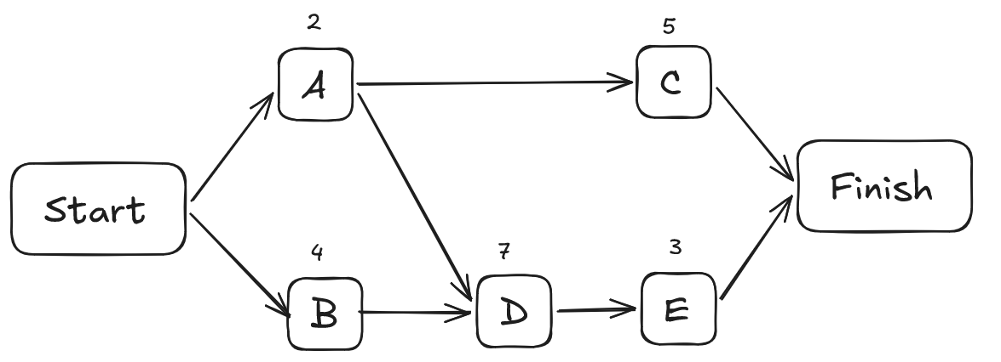
Figure: Network Diagram

4.What is the purpose of the precedence diagram method?
The Precedence Diagram Method (PDM) is a project scheduling technique used to represent activities and their dependencies in a logical sequence. It helps project managers plan, schedule, and analyze project activities effectively.
Purposes of PDM:
- Identify Dependencies: Shows the relationships between activities and their required sequence.
- Improve Scheduling: Helps create a clear and realistic project schedule.
- Identify the Critical Path: Shows activities that directly affect the project completion time.
- Determine Float: Identifies activities that can be delayed without affecting the overall schedule.
- Support Resource Planning: Helps organize resources according to task requirements and dependencies.
- Improve Communication: Provides a simple visual representation of the project workflow for teams and stakeholders.

5. Draw the precedence network diagram and Gantt Chart using MS Project.
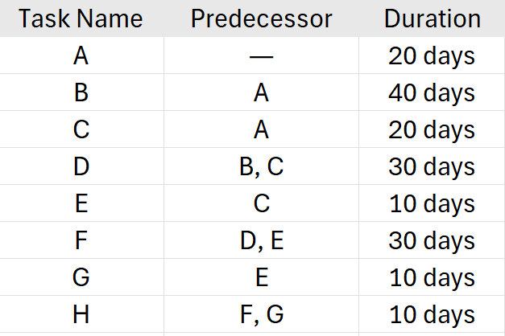
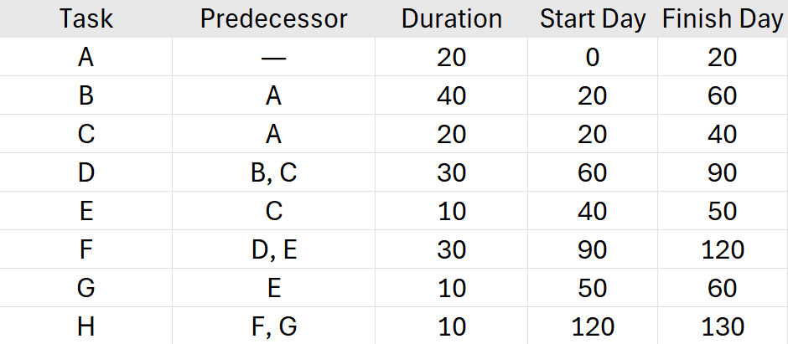
So, the project takes 130 days on this earliest-start schedule.
Gantt chart
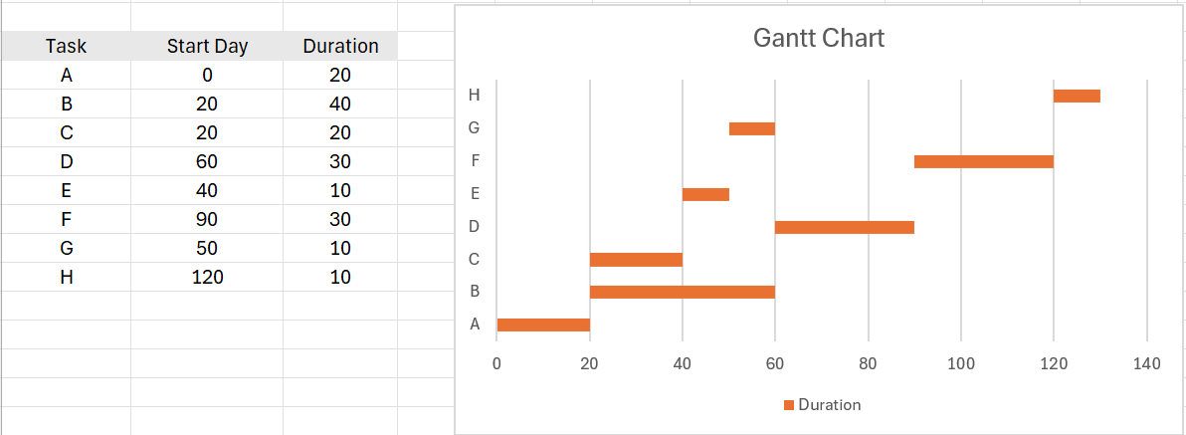

Precedence Network
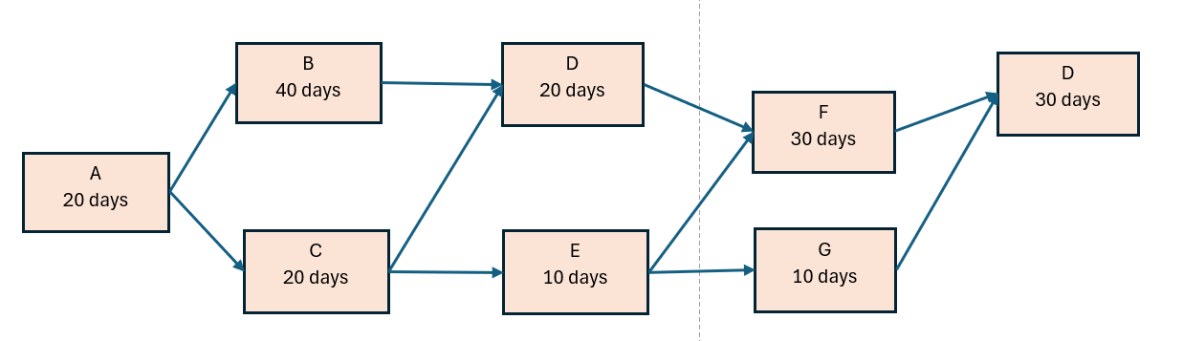

6.Draw the precedence network diagram and Gantt Chart using MS Project
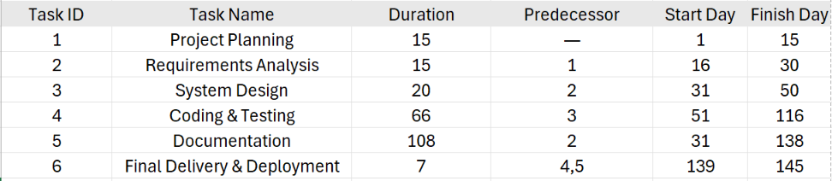
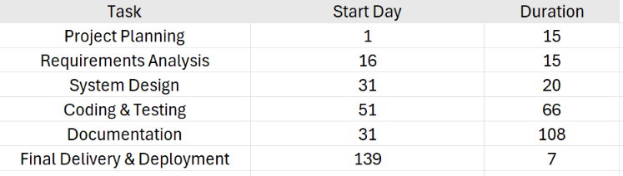

Gantt Chart:
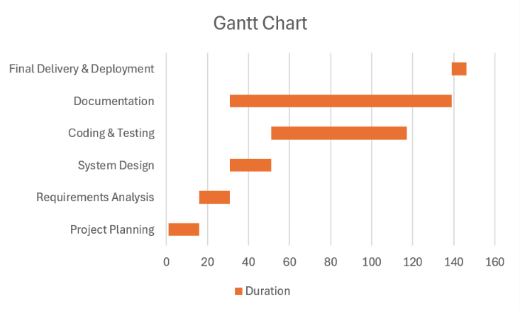
Precedence Network
